Ex.No:4: MATLAB SIMULATION Of SUPERHETERODYNE RECEIVER FOR AM COMMUNICATION SYSTEM WITH FREQUENCY MIXING AND FILTERING
Objective 1:
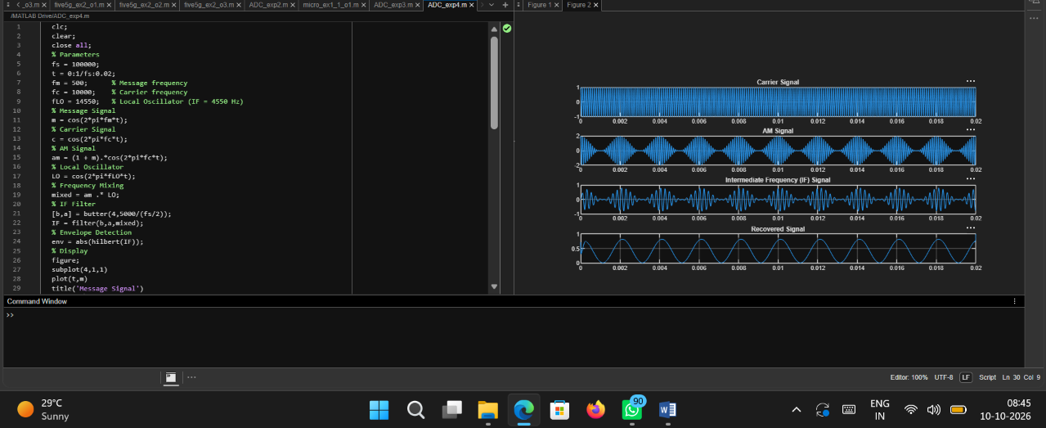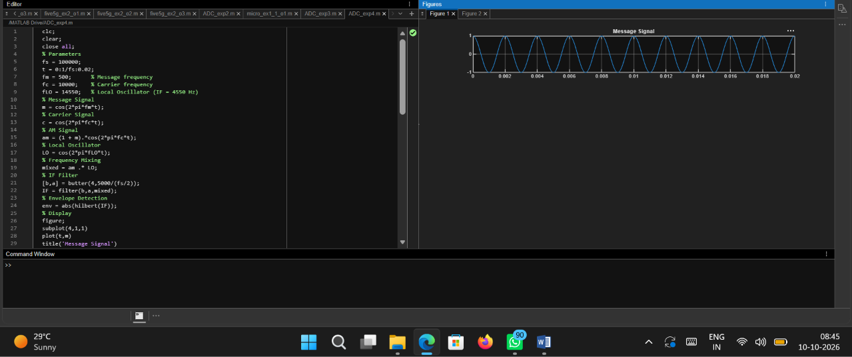

Code:
clc;
clear;
close all;
% Parameters
fs = 100000;
t = 0:1/fs:0.02;
fm = 500; % Message frequency
fc = 10000; % Carrier frequency
fLO = 14550; % Local Oscillator (IF = 4550 Hz)
% Message Signal
m = cos(2*pi*fm*t);
% Carrier Signal
c = cos(2*pi*fc*t);
% AM Signal
am = (1 + m).*cos(2*pi*fc*t);
% Local Oscillator
LO = cos(2*pi*fLO*t);
% Frequency Mixing
mixed = am .* LO;
% IF Filter
[b,a] = butter(4,5000/(fs/2));
IF = filter(b,a,mixed);
% Envelope Detection
env = abs(hilbert(IF));
% Display
figure;
subplot(4,1,1)
plot(t,m)
title('Message Signal')
grid on
figure;
subplot(5,1,2)
plot(t,c)
title('Carrier Signal')
grid on
subplot(5,1,3)
plot(t,am)
title('AM Signal')
grid on
subplot(5,1,4)
plot(t,IF)
title('Intermediate Frequency (IF) Signal')
grid on
subplot(5,1,5)
plot(t,env)
title('Recovered Signal')
grid on

Output: 